Q-MAC Fixed Helical Dipole Antenna (QM7500 Series)

Description:
The QM7500 Series Fixed Helical Dipole Antenna offers improved efficiency in a fixed base station application where there is limited space for installation up to 5 fixed frequencies may be offered with this antenna.

Assembly of the antenna is made easier by threaded mounting bolts on a metal center hub. Each frequency is pre-tuned, making installation in the field more simplified and less time consuming.

The QM7500 series antennas have an overall span of 7m and are shrink plastic coated.

Note that the QM7500 series antennas are supplied complete with 30m of RG-58 coaxial cable. No mounting structures are included.

Specifications:

ELECTRICAL  Frequency Range: 2 – 30MHz  Feed Impedance: 50Ω  Power Input: 100W Continuous duty  300W PEP  Balun: Integral 1:1  Termination: SO239  Radiation: Similar to ½ wave dipole antenna | MECHANICAL  Average weight: 8kg 5 frequency 11kg  Minimum Install Height 6m to center hub  Frontal area: 0.7m² max (5 frequency)  Overall Width: 7m  Radiating elements: Fibreglass

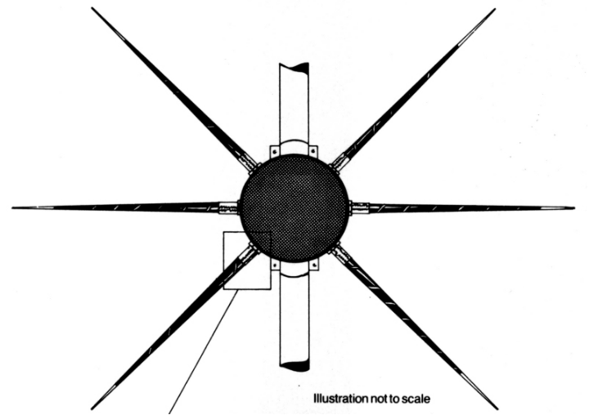
Helical Dipole Antenna.

